|  |  |  |  |
| --- | --- | --- | --- |
| 4 | | 23,724 | |
| **NUMERO DE FRONTERAS** | | **ENERGIA AGREGADA** | |
|  | | | |
| 114,957,332 | 133 | | 4,256,937 |
| INGRESO 2019 | DÍAS CERTIFICADOS 2019 | | ENERGIA RESPALDADA 2019 |
|  | | | |
| 92,641,547 | 157 | | 3,312,608 |
| INGRESO 2020 | DÍAS CERTIFICADOS 2020 | | ENERGIA RESPALDADA 2020 |
|  | | | |
| 50,693,097 | 119 | | 2,214,533 |
| INGRESO 2021 | DÍAS CERTIFICADOS 2021 | | ENERGIA RESPALDADA 2021 |

**HISTORICO REINTEGRO DDV**

|  |  |  |  |
| --- | --- | --- | --- |
|  | **2019** | **2020** | **2021** |
| **ENE** | - | 12.1 | 5.01 |
| **FEB** | - | 25.34 | 6.01 |
| **MAR** | - | 27.95 | 3.96 |
| **ABR** | - | - | 3.69 |
| **MAY** | 15.03 | - | 10.76 |
| **JUN** | 16.92 | - | 9.0 |
| **JUL** | 19.87 | 4.91 | 10.83 |
| **AGO** | 23.03 | 1.94 | 0.92 |
| **SEP** | 9.21 | 2.21 | 0.51 |
| **OCT** | 12.33 | 8.81 | - |
| **NOV** | 12.64 | 2.98 | - |
| **DIC** | 5.93 | 6.41 | - |

**Los valores de la tabla están en millones de COP**



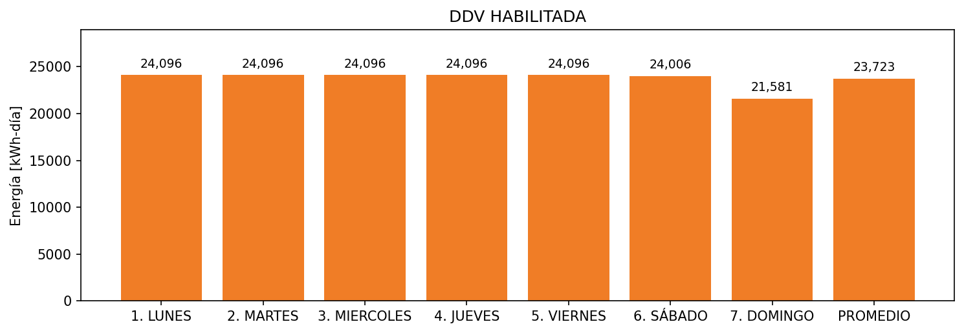

|  |  |  |  |  |  |  |  |  |  |
| --- | --- | --- | --- | --- | --- | --- | --- | --- | --- |
| **FRONTERA** | **COD SIC** | **FRT DDV** | **TIPO DDV** | **PROMEDIO** | **PRÓXIMA ACTUALIZACIÓN** | **MARGEN DE ERROR** | **ÚLTIMA PRUEBA DDV** | **DÍAS PARTICIPACIÓN** | **FECHA REFERENCIA PRÓXIMA PRUEBA DDV** |
| UNIVERSIDAD DE LOS ANDES EDIFICIO MARIO LASERNA | Frt08194 | Frt32661 | LBC | 13,038 | 2022-03-10 | 3,43 | 2021-02-09 | 89.0 | 2021-12-18 |
| UNIVERSIDAD DE LOS ANDES (BLOQUE O) | Frt02152 | Frt32659 | LBC | 4,608 | 2022-03-10 | 6,72 | 2021-02-09 | 89.0 | 2021-12-18 |
| UNIVERSIDAD DE LOS ANDES | Frt02115 | Frt36402 | LBC | 3,173 | 2022-02-10 | 7,37 | 2021-02-09 | 90.0 | 2021-12-18 |
| UNIVERSIDAD DE LOS ANDES ( EDIFICIO FRANCO) | Frt02151 | Frt32656 | LBC | 2,904 | 2022-03-02 | 4,66 | 2021-02-09 | 70.0 | 2021-12-18 |